**Mastering AI Image Captioning: A**

**Prompt Engineering Guide**

* **Introduction:** Image Captioning is a fascinating application of AI where a

model generates descriptive text for an image. It bridges computer vision

and natural language processing (NLP) to interpret visual content in a meaningful way

* **Why This Project Matters:** Enhancing Accessibility ,Social Media & Content

Creation, AI Understanding of Visual Data ,E-commerce & Automation ,Advancements

in AI & ML

* **Project Overview:**  How the Image Captioning Project Works
* **Project Goal:** The goal of this project is to develop AI-generated captions for images

using prompt engineering techniques. By carefully designing and refining prompts, we

can influence

how AI interprets and describes visual content in a more accurate, creative, and context-

aware manner.

* **Methodology:**
  1. **Defining the Caption Styles:** Captions can be descriptive, humorous, poetic, emotional ,or storytelling-based.
  2. **Collecting and Categorizing Images:** A diverse set of images (nature, people, cities, animals, abstract art, etc.) is selected.
  3. **Refining Prompt Designs:** Experimentation is done using simple vs. detailed prompts(e.g., *"Describe this image in one sentence"* vs. *"Generate a dramatic tagline for this image"*).
  4. **Evaluating AI Responses :** The most effective prompts are refined for better

readability, engagement, and emotion.

* **Improving Caption Quality :** The most effective prompts are refined for better readability, engagement, and emotion.
* **Tools Used:** To execute this project, the following tools and platforms are utilized:

**AI Models** – Copilot, GPT-based models, and computer vision tools for generating

captions.

**GitHub for Documentation** – Uploading project results and maintaining version

control

**Why This Project is Valuable:** This project enhances AI’s ability to process and describe

images effectively. It has applications in content creation, accessibility, e-commerce, and

automated visual recognition. By fine-tuning prompts, future interns can gain insights into

AI behavior and how slight changes in language can significantly alter AI-generated

responses

* **Examples & Results** :

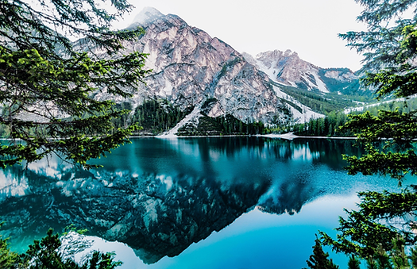

Write a caption that highlights the most interesting part of this image

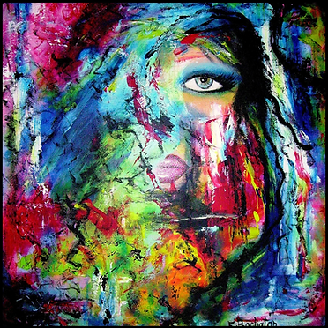**Caption Generated By AI:** A breathtaking view of towering mountains perfectly mirrored in the crystal-clear, turquoise lake—nature's symmetry at its finest.

Write an expressive caption that interprets the meaning of this art

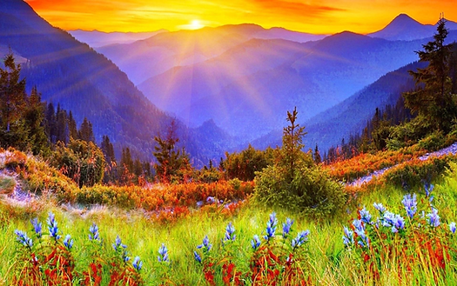**Caption Generated By AI:** Beneath the chaos of color lies a soul watching in silence—torn between beauty and pain, identity and illusion, the face of emotion emerges from the storm.

Describe this breathtaking landscape using vivid imagery and poetic language

**Caption Generated By AI:** Bathed in the golden breath of dawn, the mountains rise like ancient guardians wrapped in violet mist. Sunlight spills over their shoulders in radiant streams, kissing the wildflowers that bloom like whispers of color across the emerald meadows. A symphony of nature unfolds—where fiery reds and soothing blues dance in harmony, and the forest's hush carries secrets older 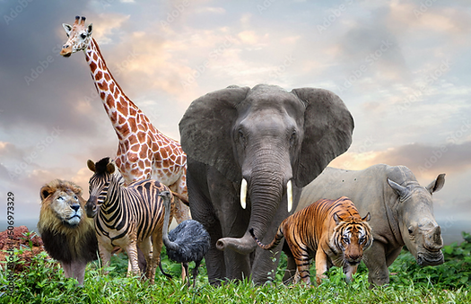than time. Here, the earth breathes beauty, and the soul finds stillness.

Write a funny caption imagining what this animal is thinking

**Caption Generated By AI:** Elephant (thinking):*"Great, the giraffe’s photobombing again, the tiger’s giving side-eye, and no one told me we were doing group pics today. I didn’t even comb my ears!"*🐘📸😅

Create a short dialogue based on this person’s pose and look

**Caption Generated By AI:** Sure! Here's a short dialogue inspired by the person in the third row, third column (the woman with hoop earrings and a thoughtful expression):

Interviewer: "You seem deep in thought. What’s on your mind?"

Her: *(softly smiling)* "Just thinking about how far I’ve come… and how much further I want to go.

Every challenge I’ve faced became a step forward, not a setback."

Interviewer: "That’s powerful. What drives you?"

Her: "The future I’m building — not just for me, but for those who believe in me."

* **Challenges & Learnings:** While working on this image captioning prompt engineering project,several interesting challenges and insights emerged. Here’s a look at some of them:

**Challenges Faced:**

* 1. **Generating Contextually Accurate Captions:** Some AI-generated captions were too generic or didn’t fully capture the depth of the image.
  2. **Balancing Creativity with Accuracy:** Finding the right balance between descriptive accuracy and creative expression was tricky.
  3. **Prompt Sensitivity & Refinement :** Even small changes in wording significantly impacted the AI’s output
     + **Key Learnings:**
       1. ✅ **Prompt Design is Powerful** – Slight tweaks to phrasing directly affect AI’s

interpretation, making prompt engineering a valuable skill.

* + - 1. ✅ **Clear Objectives Matter** – Defining whether a caption should be factual, emotional, or creative helped in guiding AI responses more effectively
      2. ✅ **Practical Applications Are Vast** – AI-generated captions can enhance accessibility, social media engagement, automated image indexing, and storytelling.

**Conclusion:**

* This Image Captioning Prompt Engineering Project highlights the incredible potential of AI in interpreting and describing visual content. Through careful prompt design and refinement, AI-generated captions can
* be more accurate, engaging, and contextually relevant.

**Key Takeaways:**

✅ **Prompt Engineering Matters** – The way we structure prompts directly impacts AI responses, making careful phrasing a valuable skill.

✅ **Creativity vs. Accuracy** – AI captions need a balance between descriptive precision and creative storytelling.

* **Future Improvements:**

🔹 Fine-tuning AI models for better image understanding and context-aware captioning.

🔹 Exploring multimodal AI that combines text prompts with voice or interactive input for more dynamic captions.

🔹 Developing customized AI tools for fields like marketing, accessibility, and automated content creation.